

Sukkur IBA University Kandhkot Campus
Department of Computer Science

Applied Physics, Spring 2025

Lab Handout # 03: SERIES CIRCUITS

Instructor: Engr. Sahib Khan

Name: __________________________________ Date: ________________________
Score: __________________________________Signature of Instructor___________

PERFORMANCE OBJECTIVE:
- To learn the basic concepts and relationships of current and voltage measurements in DC circuits containing resistors wired in Series Circuits.
- To understand and use Ohm’s Law applied to Series Circuits.
- To learn the relationships of the total resistance of resistors connected in Series Circuits.
- To learn to use ammeters, voltmeters, ohmmeters, and multimeters to properly measure voltages, currents, and resistances.
EQUIPMENT AND COMPONENTS
- Multimeter
- Power supply
- Connecting Leads
- Breadboard
- Few Resistors
- Ohmmeter
- Voltmeter
- Ammeter
Introduction
Most common household electrical circuits are made of many devices connected in parallel. Each device is hooked to the power source in parallel with all the other devices, each connected to the same voltage source and availing itself of the same voltage. Each device has its own characteristic resistance, and therefore each draws from the source a different amount of current, depending on its resistive value. While the voltage being accessed is nearly the same for all devices, the amount of current drawn from the source increases as each device draws its respective current based on its resistance. As a result as more and more devices are connected in parallel, the total amount of current drawn from the source increases. It thus has the effect of causing the resistance to decrease with each additional resistance added. Additional devices added to a circuit, require additional current from the source until something is overloaded. More current is required beyond that which can be supplied by the source or carried by the conductors without burning up.
Theory
Ohm’s Law
Ohm’s Law is the relationship between the current I flowing through a resistance R and the potential drop across it V. The current is directly proportional to the potential difference across the resistance and is inversely proportional to the resistance,
I=V/R (1)
As an alternative, Ohm’s Law may be stated as: The potential difference V across a resistance is directly proportional to the current I flowing through the resistance and the resistance R, or

V=I ×R (2)

Ohm’s Law can be rearranged to define the resistance R so that
R=V/I (3)
If the potential difference across the resistance is measured in volts (V) and the current flowing through the resistance is measured in amperes (A), then the resistance values will be in units of ohms.
Resistors in Series

Figure 1 shows 3 resistors, R₁, R₂, and R₃, connected in series in a closed circuit powered by a single battery or Emf source. In this circuit the current supplied by the battery flows through each resistor, with the current in each resistor being the same. If the current supplied by the battery is I_{T}, the current in each resistor is I₁, I₂, and I₃, and they are all one and the same, then
I_{T} = I₁ = I₂ = I₃ (4)
The voltage drop across the battery V_{T} will be the total sum of the individual drops across each of the 3 resistors, and

V_{T}=V₁+V₂+V₃ (5)

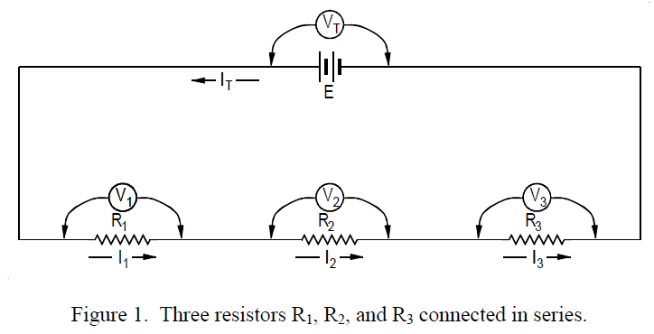
Where V₁ is the potential difference across R₁, V₂ is the potential difference across R₂, and V₃ is the potential difference across R₃. From Equation 2,

V_{T}=I_{T} × R_{T} (6)

V₁=I₁ × R₁ (7)

V₂=I₂ × R₂ (8)

V₃=I₃ × R₃ (9)

Substituting these equations into Equation 5 gives

I_{T} R_{T} = I₁ R₁ + I₂ R₂ + I₃ R₃ (10)

Since I_{T} = I₁ = I₂ = I₃
R_{T} = R₁ + R₂ + R₃ (11)

Therefore, when resistors are connected in series, the total resistance is just the sum of the individual resistances. While this has been shown for 3 resistors, the total resistance of any number of N (N≥2) of resistors connected in series, end to end, can be found using the same general procedure. Therefore for resistors connected in series
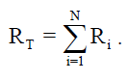
(12)

PROCEDURE:
1.With an ohmmeter measure the each resistor value for the resistors required for this experiment, take resistances of your own choices available. Connect the resistors in series and 2.measure the total resistance R_{T}. Record the results in Table 1.
3.Using the information given in Theory and Figure 1, calculate the total resistance R_{T}, the series current I_{T}, and the IR voltage drop across R₁, R₂, R₃. Record the result in Table 2. Take voltage and resistances of your choice available in the Lab.
4.Connect the circuit shown in Figure 1 and turn on the DC Power Supply, adjust the power supply level to 10V DC.
5.Measure the IR voltage drop across each resistance as indicated in the Figure 1 and record the result in Table 2.
6.Repeat the procedure for 15V DC and fill the Table 3.
7.After recording the measured voltage drops, compare the measured and calculated values. Use the formula for determining the percentage.
%=Difference between Measured and Calculated × 100
Calculated
TABLE 1
S.NO | Calculated Resistance(Nominal) | Tolerance Range | Measured Resistance
1 | R₁
2 | R₂
3 | R₃
4 | R_{T}

TABLE 2
Value | Calculated | Measured | % Error
R_{T}
I_{T}
V_{R1}
V_{R2}
V_{R3}

TABLE 3
Value | Calculated | Measured | %Error
R_{T}
I_{T}
V_{R1}
V_{R2}
V_{R3}

CONCLUSION

